Power BI Basics Assignment
Name: Rahul sharma

Question1.
What is Power BI and why is it used in businesses?
Ans.
Power BI is Microsoft’s business intelligence and data visualization platform. It’s a collection of software services, apps, and connectors that work together to turn raw, scattered data into interactive dashboards and reports. It can pull data from spreadsheets, databases, cloud services, and even APIs, then transform that data into clear, visual insights that are easy to understand and share .
Business use:
Businesses adopt Power BI because it helps them move from data overload to data-driven decisions. Here are the main reasons:
1 Centralized Reporting
Combines data from multiple sources (Excel, SQL databases, cloud apps).
Ensures everyone works with the same, up-to-date information.
2 Interactive Dashboards
Visualize KPIs with charts, maps, and graphs.
Drill down into details with just a click.
3 Cloud-Based Collaboration
Hosted on Microsoft Azure, so teams can access reports anywhere.
Easy sharing across departments with role-based access .
4 Improved Decision-Making
Provides real-time insights rather than static reports.
Helps leaders spot trends, risks, and opportunities quickly .
5 Scalability & Integration
Works seamlessly with other Microsoft tools (Excel, Teams, SharePoint).
Scales from small businesses to enterprise-level analytics

Question2.
Name and explain the three main components of Power BI.
Ans.
Power BI is built around three main components that work together to handle the full cycle of data analysis:
1. Power Query
Purpose: Data connection and transformation.
What it does: Lets you import data from multiple sources (Excel, SQL, cloud services, APIs) and clean/reshape it before analysis.
Example: Removing duplicates, renaming columns, merging tables, or filtering rows.
Business value: Ensures raw data is structured and reliable before visualization.
2. Power Pivot
Purpose: Data modeling and calculations.
What it does: Creates relationships between tables, builds measures using DAX (Data Analysis Expressions), and performs advanced calculations.
Example: Calculating year-over-year growth, profit margins, or customer churn rates.
Business value: Provides a powerful analytical engine to uncover deeper insights from complex datasets.
3. Power View
Purpose: Data visualization and reporting.
What it does: Generates interactive charts, graphs, maps, and dashboards.
Example: A sales dashboard showing revenue trends by region, product category, and time period.
Business value: Makes insights easy to understand and share across teams, enabling faster decision-making.

Question3.
Explain the Power BI workflow.
Ans.
The Power BI Workflow are:
1 Data Import (Get Data)
Connect to multiple sources: Excel, SQL databases, cloud apps, APIs.
Power Query is used here to pull in and prepare the data.
2 Data Cleaning & Transformation
Handle missing values, remove duplicates, rename columns, and reshape tables.
Ensures data quality before analysis.
3 Data Modeling
Define relationships between tables.
Create measures and calculated columns using DAX (Data Analysis Expressions).
Builds the analytical foundation for reports.
4 Visualization (Report Building)
Use Power View and other visualization tools to design dashboards.
Add charts, maps, KPIs, and slicers for interactivity.
5 Sharing & Collaboration
Publish reports to the Power BI Service (cloud).
Share dashboards with teams, set permissions, and enable collaboration.
6 Data Refresh & Maintenance
Schedule automatic refreshes to keep reports up to date.
Monitor performance and adjust models as business needs evolve.
Question4.
List any four data cleaning tasks that can be performed in Power Query.
Ans.
Here are four common data cleaning tasks you can perform in Power Query within Power BI:
1. Remove Duplicates
Ensures each record appears only once.
Example: If a customer ID appears multiple times, you can remove duplicates to avoid double-counting.
2. Handle Missing Values
Replace nulls with default values, forward-fill, or remove rows.
Example: Filling missing sales figures with the average of available data.
3. Rename and Reformat Columns
Make column names clear and consistent.
Example: Changing “Cust_ID” to “Customer ID” or converting text dates into proper date formats.
4. Filter and Sort Data
Keep only relevant rows and order them logically.
Example: Filtering out canceled orders or sorting transactions by date.

Question5.
Write step by step instructions to load the above dataset.
Ans.
Steps to Load Excel Data in Power BI:
1 Open Power BI
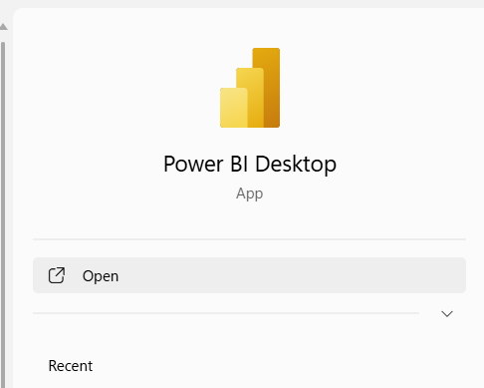

2 Click on Get Data
On the Home ribbon, select Get Data.
A dropdown menu will appear with multiple data source options.
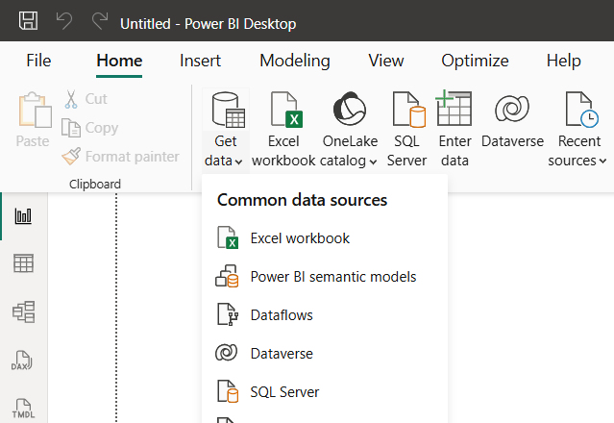

3 Choose Excel
From the list of sources, click Excel.
This opens a file picker window.
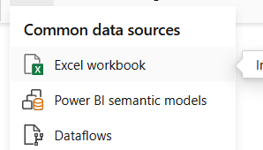

4 Browse and Select Your Excel File
Navigate to the folder where your Excel dataset is stored.
Select the file and click Open.
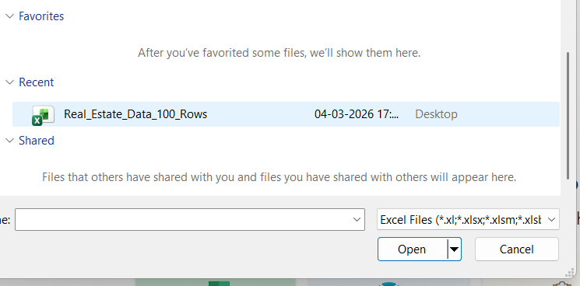

5 Navigator Window Appears
Power BI will display a Navigator pane showing all sheets and tables in the Excel file.
You can preview the data before loading.
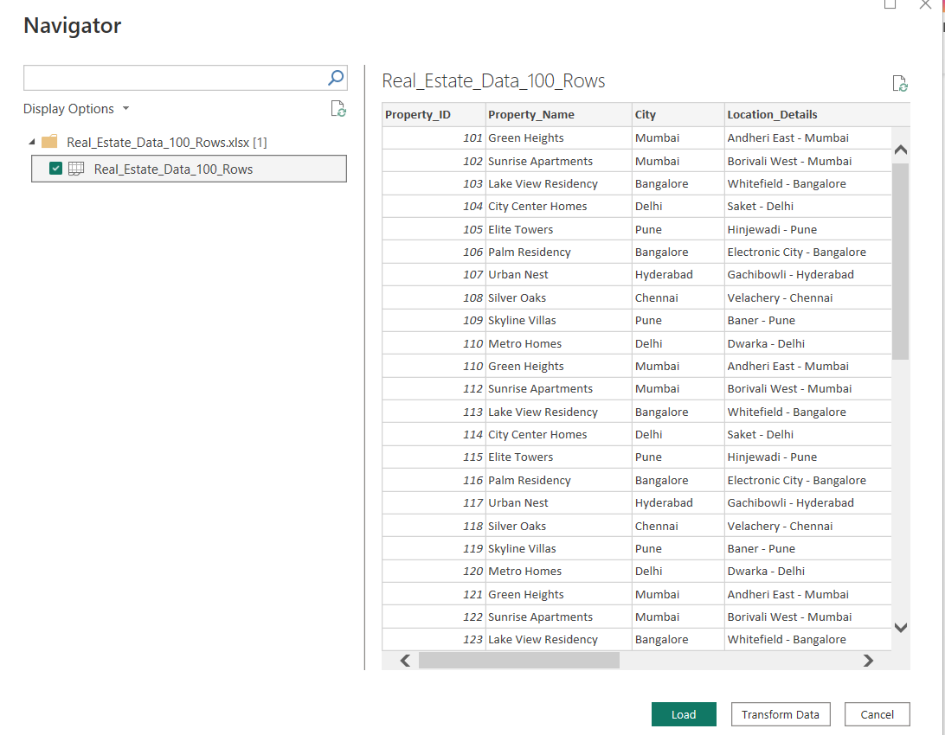

6 Select the Desired Sheets/Tables
Tick the checkboxes for the sheets or tables you want to import.
You can select multiple sheets if needed.
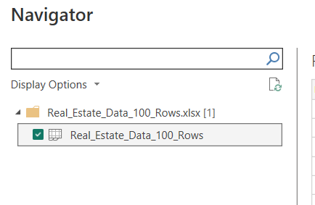
7 Choose Load or Transform Data
Load: Directly imports the data into Power BI.
Transform Data: Opens Power Query Editor, where you can clean and reshape the data before loading.
Since, I have to perform some task on dataset, so will opt for Transform data instead of Load data.

8 Data Appears in Power BI Fields Pane
Once loaded, the dataset will be visible in the Fields pane on the right side of Power BI Desktop.
You can now start building reports and dashboards.
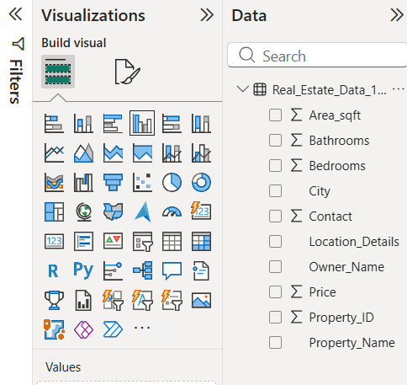

Question6.
Define Data View, Report View, and Model View. Explain the purpose of each view.
Ans.
In Power BI Desktop, you work with your data through three main views. Each serves a different purpose in the workflow:
1. Data View
Purpose: To inspect and explore the actual data you’ve loaded into Power BI.
What you see: Tables with rows and columns, similar to a spreadsheet.
Use case:
Check if data has loaded correctly.
Verify transformations (e.g., split columns, remove duplicates).
Perform quick checks on values before modeling or visualization.

2. Report View
Purpose: To design and build interactive dashboards and reports.
What you see: A canvas where you can drag fields to create charts, maps, KPIs, and slicers.
Use case:
Create visualizations to represent insights.
Arrange visuals into dashboards.
Add interactivity (filters, drill-downs).
Share reports with others.
3. Model View
Purpose: To define relationships and structure between tables.
What you see: A diagram of tables, fields, and relationships (like a database schema).
Use case:
Establish relationships between tables (e.g., Sales linked to Customers).
Manage cardinality (one-to-many, many-to-many).
Create hierarchies (e.g., Year → Quarter → Month).
Ensure the data model supports accurate calculations and visuals.

Question7.
Discuss the different data sources that Power BI supports.
Ans.
Power BI supports a wide variety of data sources, making it flexible for different business needs. These sources can be grouped into categories:
1. Flat Files
Examples: Excel, CSV, XML, JSON.
Purpose: Simple datasets stored locally or shared across teams.
Use case: Importing sales records from Excel or customer lists from CSV.
2. Databases
Examples: SQL Server, Oracle, MySQL, PostgreSQL, Access.
Purpose: Connect directly to relational databases for structured data.
Use case: Pulling transactional data from a company’s ERP or CRM system.
3. Cloud Platforms
Examples: Microsoft Azure (Azure SQL Database, Azure Data Lake, Azure Blob Storage), Amazon Redshift, Google BigQuery.
Purpose: Handle large-scale, cloud-hosted datasets.
Use case: Analyzing big data stored in cloud warehouses.
4. Online Services
Examples: Salesforce, Google Analytics, Facebook, Dynamics 365, SharePoint, GitHub.
Purpose: Connect directly to SaaS applications and online platforms.
Use case: Tracking marketing performance from Google Analytics or customer interactions from Salesforce.
5. Other Sources
Examples: Hadoop, Exchange, Active Directory, OData feeds, APIs, and ODBC connections.
Purpose: Extend Power BI to specialized or custom data sources.
Use case: Integrating organizational directories or pulling data from custom APIs.

Question8.
Split Owner Name to create two new columns as First Name and Last Name.
Ans.
1 In the Power Query Editor, select the column Owner Name.
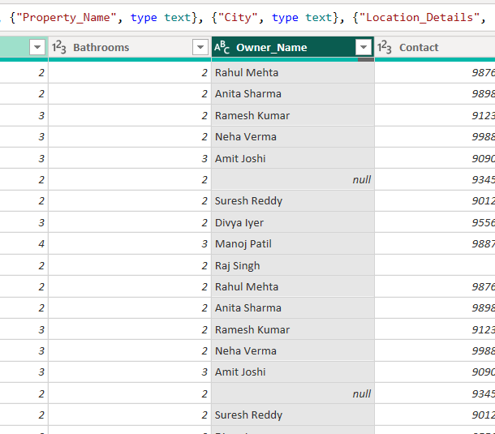
2 On the ribbon, go to Home , Split Column , By Delimiter.

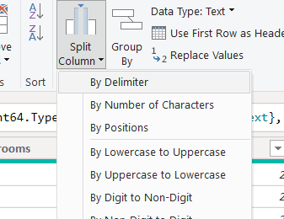

3 Choose Space as the delimiter.

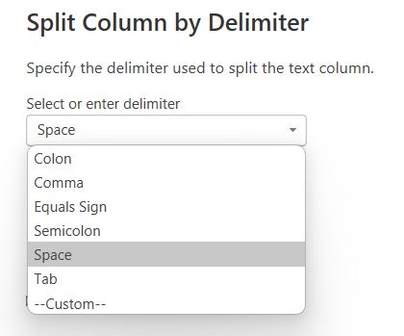

4 Power Query will create two new columns:
Owner Name.1
Owner Name.2
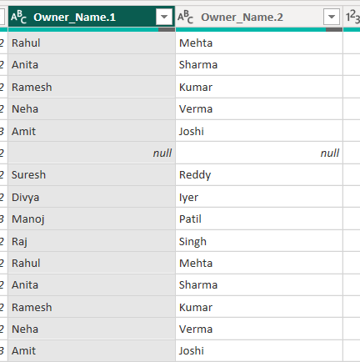

5 Rename them to First Name and Last Name.
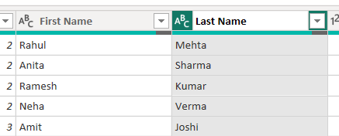

6 Click Close & Apply to save changes and load the transformed data into Power BI.
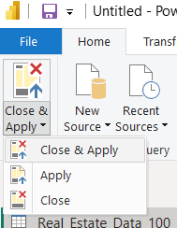

7 Now you can see, both the columns have been added to the dataset.
